OOP Concepts:
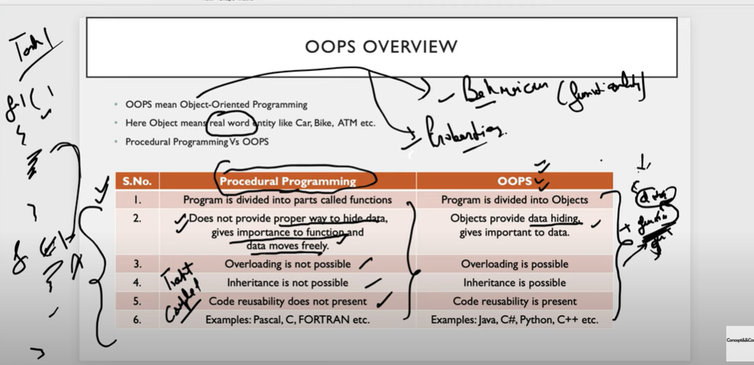

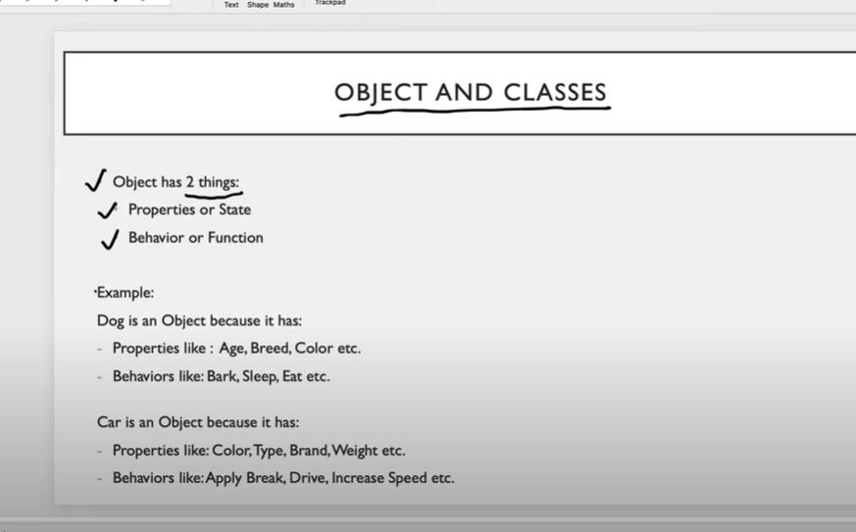

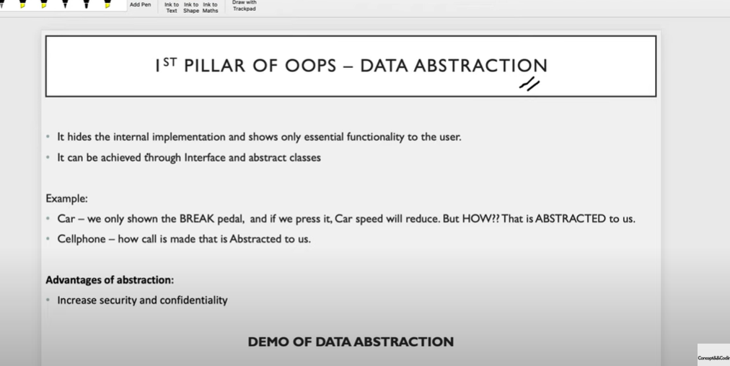
We don’t want to expose internal steps to user.
It will make things complicate.
Like if you are building software, do you need to know everything about framework code?
Data Hiding
